Led Chaser using 4017 decade counter and 555 Timer
555 Timer
The 555 timer is capable of being used in astable and monostable circuits. In an astable circuit, the output voltage alternates between VCC and 0 volts on a continual basis.By selecting values for R1, R2 and C we can determine the period/frequency and the duty cycle.The period is the length of time it takes for the on/off cyle to repeat itself, whilst the duty cycle is the percentage of time the output is on. ie. T1/T.In this type of circuit, the duty cycle can never be 50% or lower.

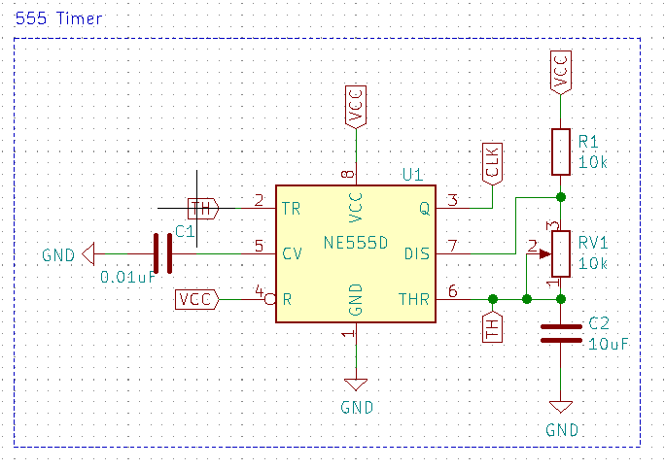

We used the above circuit to produce a square wave in which the high time (T1) and low time (T2) can be calculated. This method can be used to generate clock pulses for Microcontrollers/Digital IC’s or blink an LED or any other applications where specific time intervals are needed. The output wave obtained from pin 3 is shown with markings below
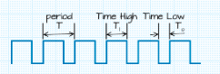

The following formulas are use to calculate the values of the components used:
Parameter | Formulae | Unit
Time High (T1) | 0.693x(R1+R2)xC1 | Seconds
Time Low (T2) | 0.693 × R2 × C1 | Seconds
Time Period (T) | 0.693 × (R1+2×R2) × C1 | Seconds
Frequency | 1.44 / (R1+2×R2) × C1 | Hertz (Hz)
Duty Cycle | (T1/T)×100 | Percentage (%)

In our circuit diagram the value of Resistors R1 is 10K and R2 is a 10k variable resistor respectively, the value of capacitor C1 is 10uf. Using the above formulas we obtained the following values:
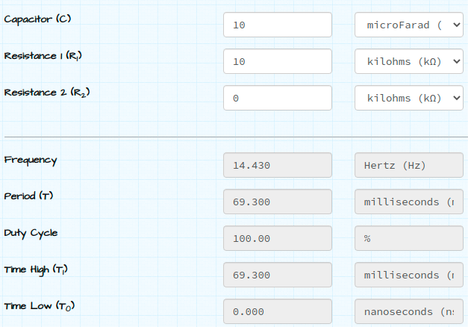
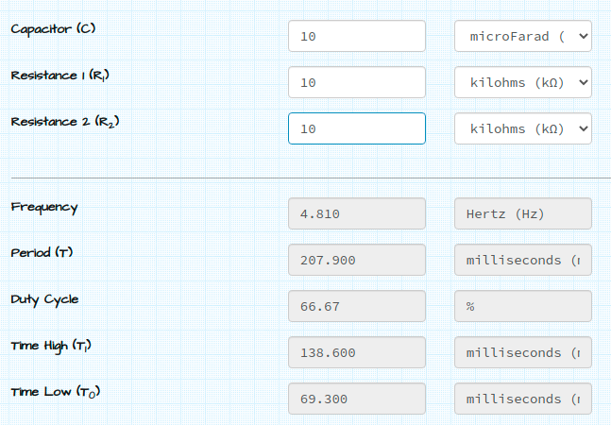

Conclusion
Increasing C will increase the cycle time (and hence, reduce the frequency).
Increasing R1 will increase Time High (T1), but will leave Time Low (T0) unaffected.
Increasing R2 will increase Time High (T1), increase Time Low (T0) and decrease the duty cycle

